**Experiment No : 6**

**AIM**

Familiarization of LINUX Commands.

**CO2**

Perform system administration task.

**Procedure**

1. grep

grep command is used to filter and display contents accordingly which makes our search easy.

* 1. grep –i [pattern] [filename]

used to search the pattern and display contents accordingly, -i implies the search is insensitive.

$grep –i hindi mark

Output

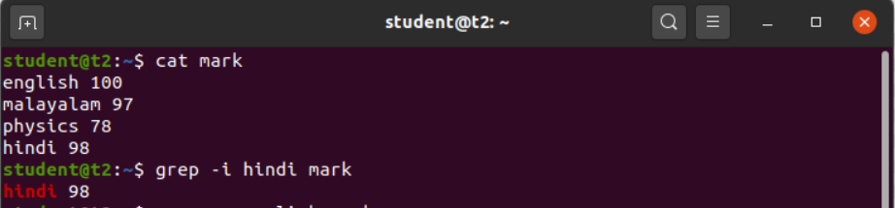

* 1. grep –v [pattern] [filename]

performs inverted search which implies displaying all the contents which does not have the specified pattern.

$ grep –v english mark

Output



* 1. grep –A1 [pattern] [filename]

displays the searched content along with a line after it.

$ grep –A1 physics mark

Output



* 1. grep –B1 [pattern] [filename]

displays the searched content along with a line before it.

$ grep –B1 physics mark

Output



* 1. grep –C1 [pattern] [filename]

displays the searched content along with a line before and after it. It works as a combination of –A1 and –B1 option of grep command.

$ grep –C1 malayalam mark

Output



1. head

displays the top contents of a file. By default, it displays first 10 lines of file.

$ head number

Output

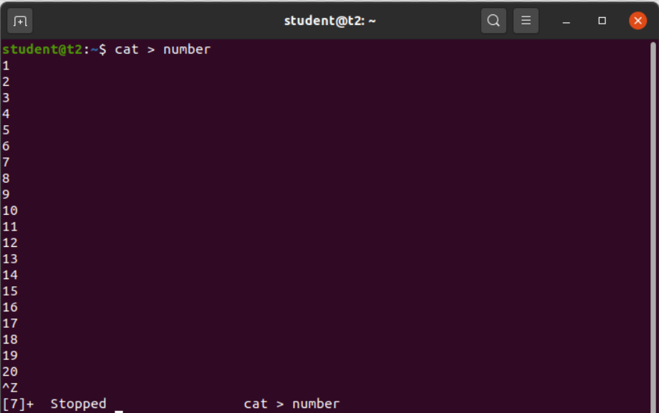

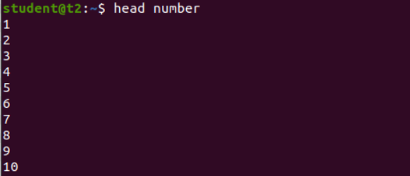

* 1. head –[number of lines] [filename]

displays only the number of lines specified by the user.

$ head -5 number

Output

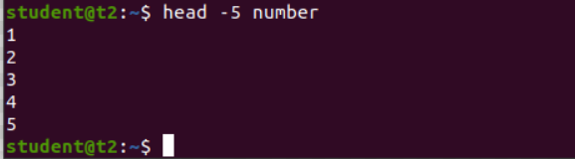

1. tail

displays the bottom contents of a file. By default, it displays last 10 lines of file.

$ tail number

Output

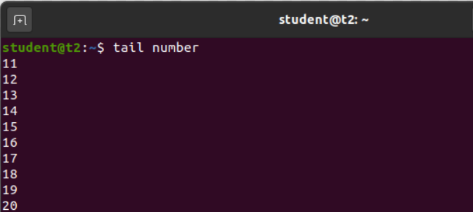

* 1. tail –[number of lines] [filename]

displays only the number of lines specified by the user.

$ tail -5 number

Output

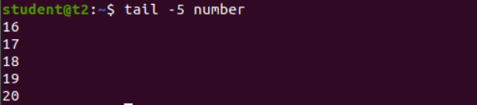

4) mv [source file] [copy file]

To move the contents of file 1 to file 2 by overwriting the contents of file and replacing it with new name.

$ mv number number1

Output

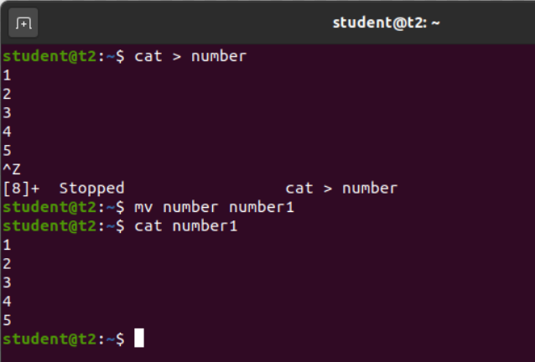

4.1) mv –b [source file] [copy file]

To move the contents of file 1 to file 2 while keeping a backup of original file.

$ mv –b hello hi

Output

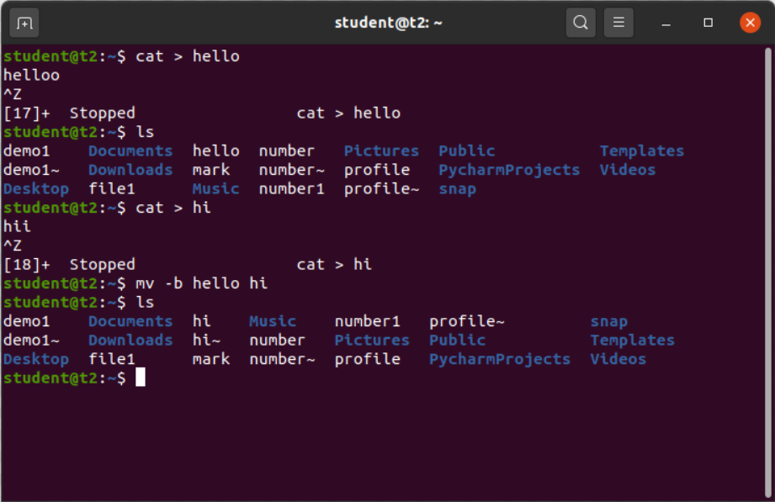

4.2) mv –i [source file] [copy file]

To move the contents of file 1 to file 2 by overwriting the original file.

$ mv –i hello hi

Output

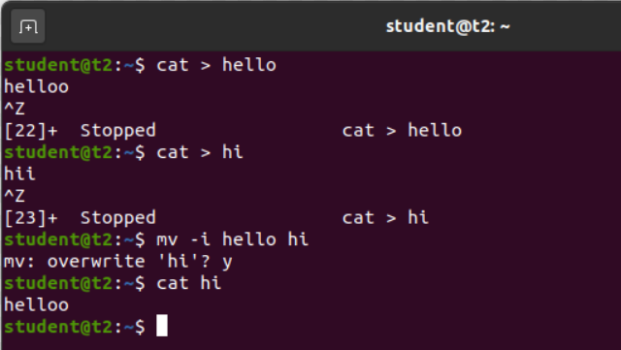

Result

The program has been executed and output has been verified.